So, the program basically reads data from a table called z_employees and we have multiple select statements that act as loops, so it'll read the first record, write out the record to the screen, then end the loop, and it'll keep going round until all the records have been read, and output to the screen from that table. Underline. And it does the loop again. Underline. Loop again, with some slightly different output to the screen, by introducing new lines.

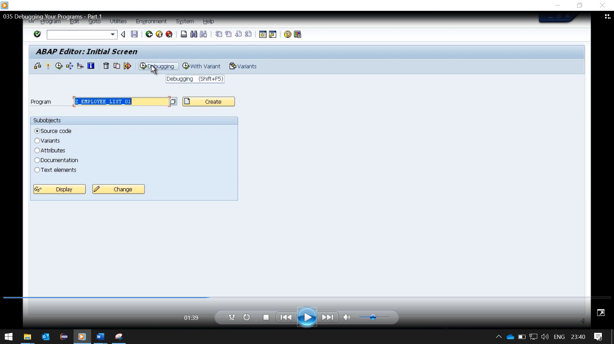

Step back just to the main screen of SE38 and we can start debugging this program in several ways, and the first way we'll see is we have an option here on this toolbar called debugging, which is SHIFT F5.

If we have the program and the program import box, we can click the debugging window and it will take us into a debugging session at the first line of code within our program. So here we go. We've entered the debugger, and you can see we've got a blue arrow pointing at the report statements.

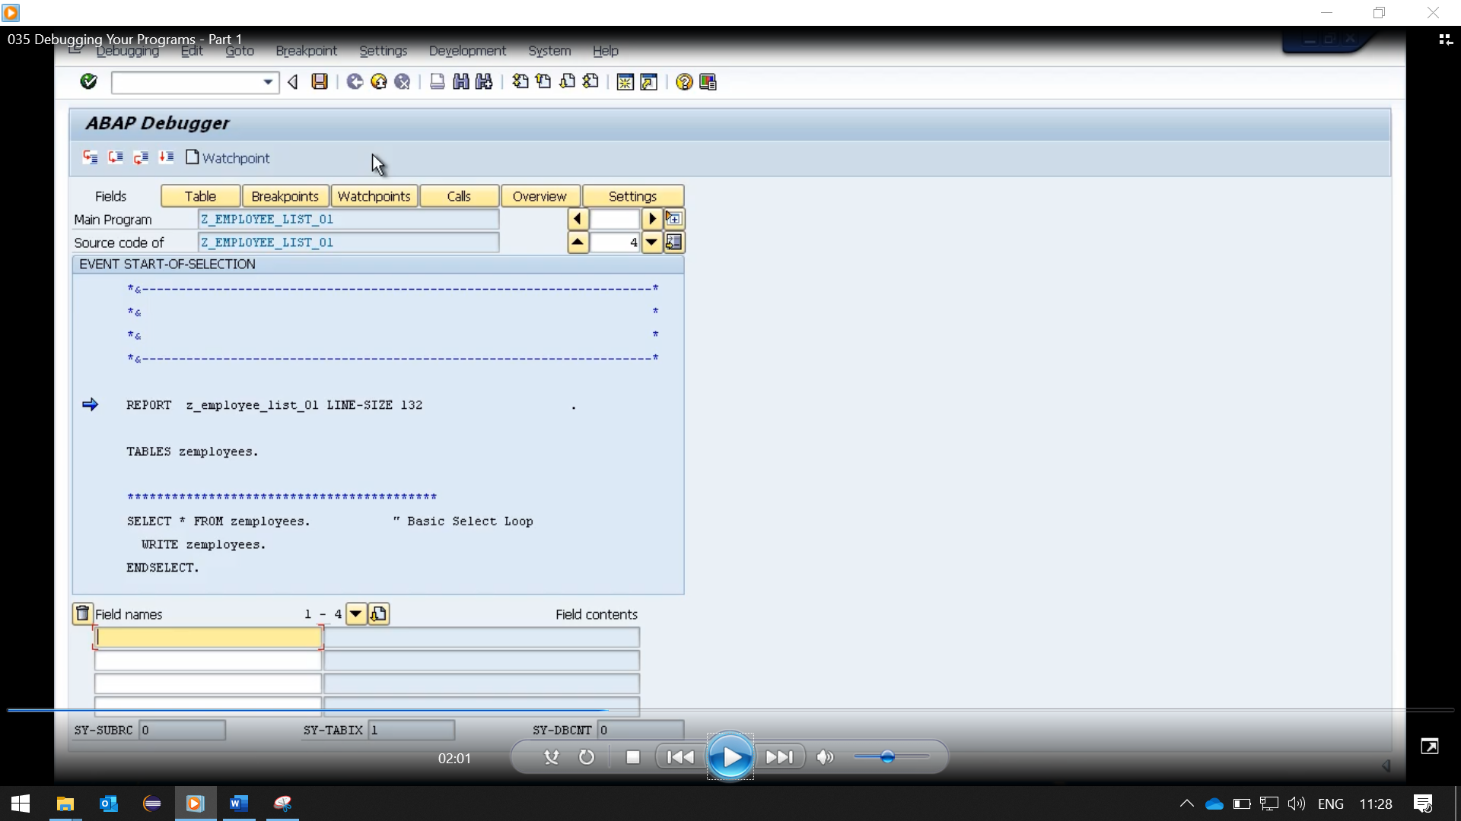

And that's the first line of code within our program. Now I'll step back and show you an alternative way of debugging.

If we go and look at the code itself, now we have the option of setting what I called break points on our code. And we'll come to break points very shortly, but for now I'll just set one.

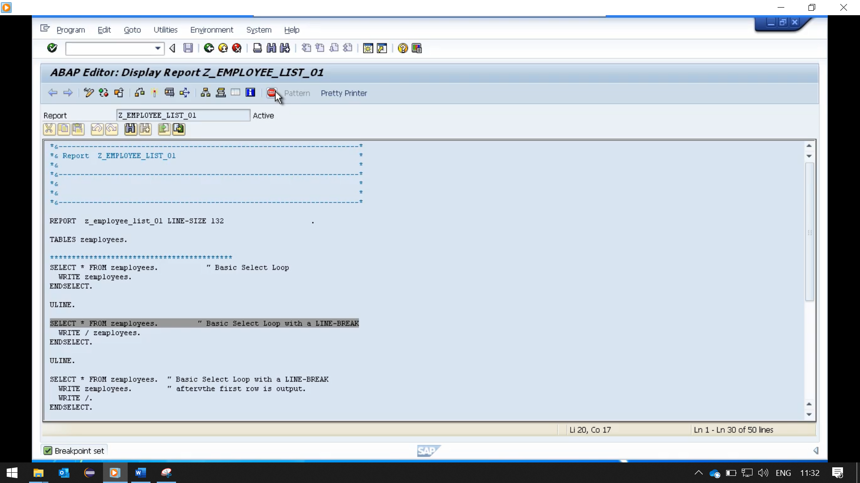

So, I'm going to place my cursor on the line of code and click this stop icon. And that will set a break point on this line of code, which will force the program to stop executing our code and take us directly into a debugging session. So, if we execute the program, you'll see it's very fast.

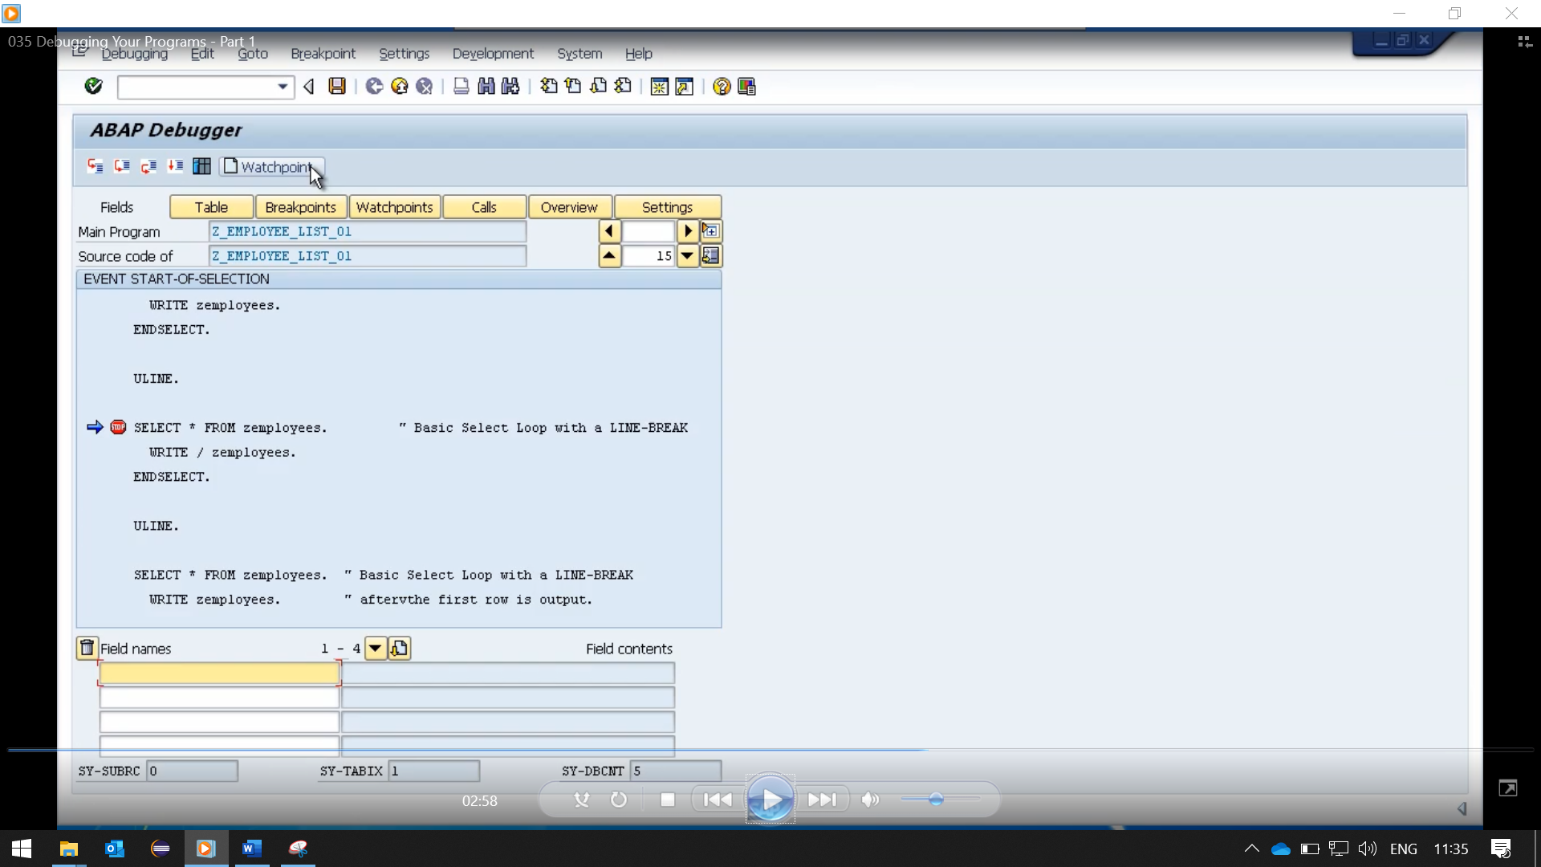

The program started to execute, and then as soon as it got down to the line of code where we set a break point the debugging session kicked in and we have the blue arrow identifying the line of code that we can start debugging from. And I'll say, this is my preferred way of debugging a program, because often, you don't want to start at the very start of your program. You have a good idea of where the issues are, so you'll normally set a break point, let the program zoom through to it, and t­­­­­hen start debugging line by line from that point on.

Now I briefly mentioned rate points there. And I will just explain there are two type of rate points that you can set in your program. Static rate points, which we will come to in a little while, and dynamic rate points. And that is what I set just there. An important point to keep in mind about dynamic rate points is that they are only valid for the current session. So, if you come out of your sub-gui and go back in later, your break point will no longer exist.

So just step back to the program. I've just mentioned that here is another way of setting a break point. And that's within your debugging session itself. You can just double click on any statement and a break point will be set. So, for example, I'll just double click here, and you'll see a break point is set. To remove your break point, just double click the stop sign. And it's gone.